Sedimentary rocks  This type of rock is made out of sand, shells, pebbles and other materials, which we call sediment. Slowly the sediment gathers up in layers, usually at the bottom of lakes and oceans, and is then compressed over thousands of years. Over time it turns into rocks! Fossils are usually found in this type of rock.  How did we make it:  You are exerting pressure on the pieces of chocolate in order to form a sedimentary rock out of those pieces. | Metamorphic rocks  The conditions required to form a metamorphic rock are very specific. The existing rock must be exposed to high heat, high pressure, or to a hot, mineral-rich fluid. These conditions are most often found either deep in Earth’s crust or at plate boundaries where tectonic plates collide. In order to create metamorphic rock, it is vital that the existing rock remain solid and not melt. If there is too much heat or pressure, the rock will melt and become magma. This will result in the formation of an igneous rock, not a metamorphic rock.  How did we make it:  We heated chocolate shavings, pieces of sedimentary and igneous rocks over a candle until it all melted together. | Igneous rocks  This type of rock is made from the lava of a volcano. Deep inside the earth, rocks are melted and become magma. When magma comes out of the volcano, it is called lava. If the lava cools quickly, it will make a smooth shiny rock. If the lava cools slowly, it will form a rock with tiny holes and gas bubbles in.  How did we make it:  We heated shavings of chocolate in a cup of boiling water.
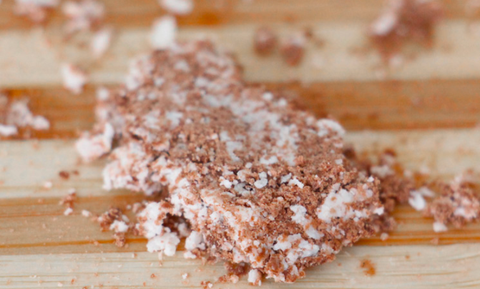 | 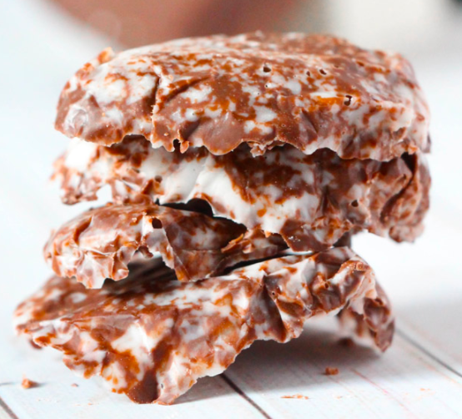 | 